**How I built the database for this SQL project**

1. Open pgAdmin 4. Navigate to database > right click > create > database. A pop-up window will appear. Type the name > save.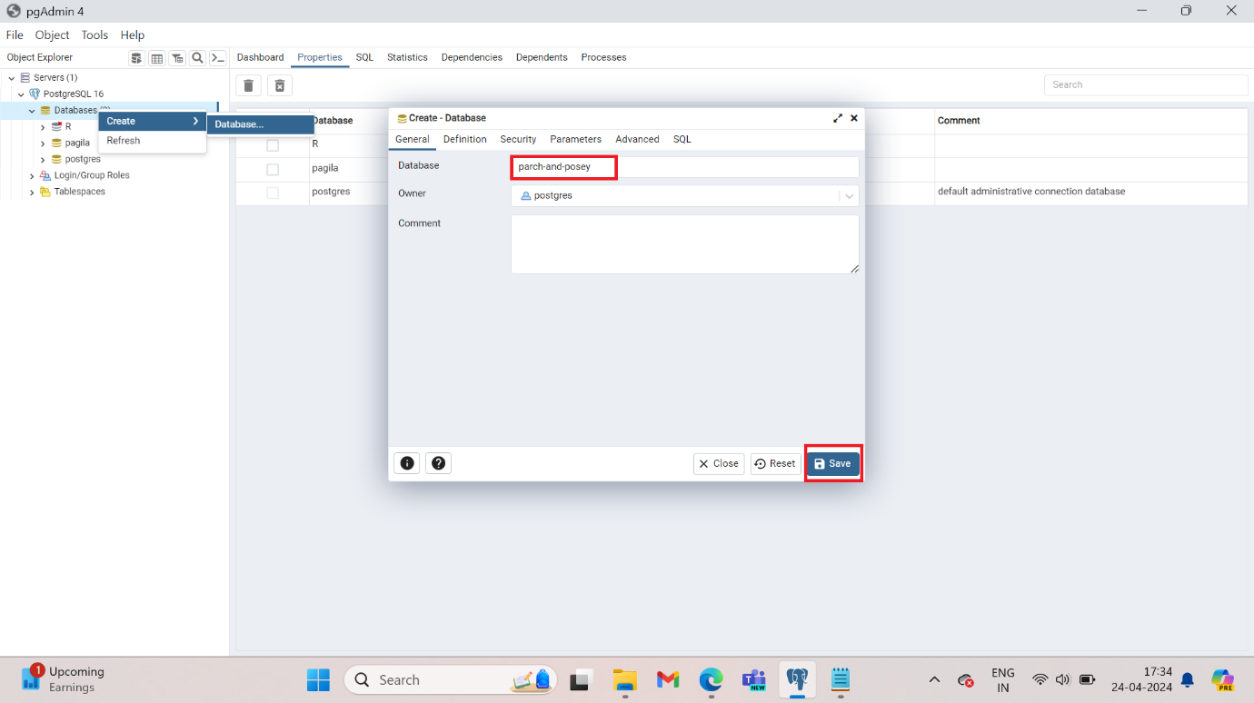
2. Click on the query tool button. Now create the tables in this database

CREATE TABLE web_events (

id integer,

account_id integer,

occurred_at timestamp,

channel bpchar

);

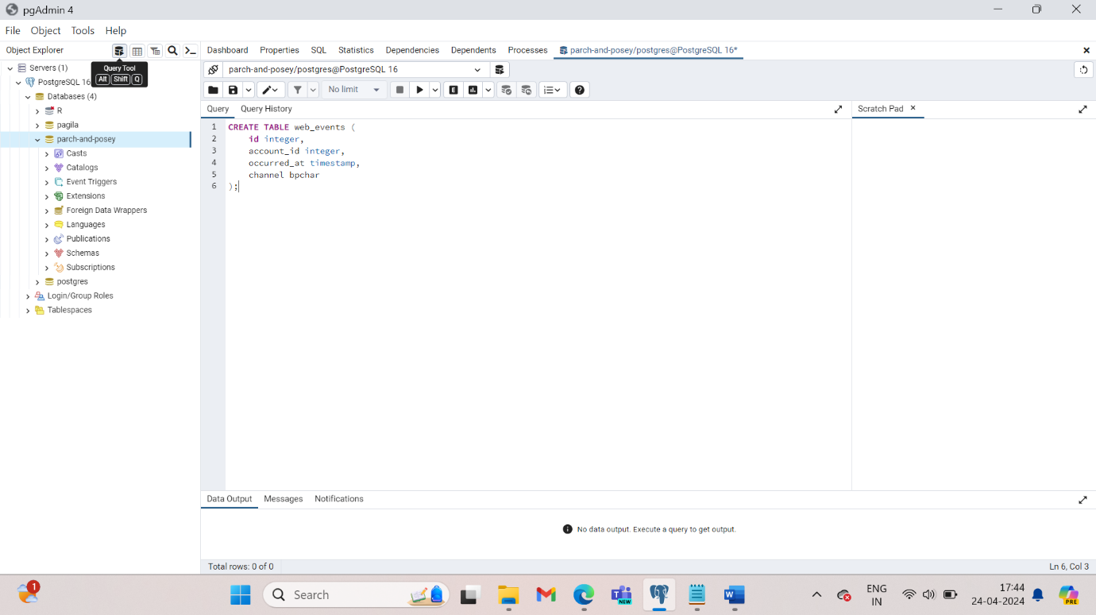

Select the command > click run/referesh. This will show a message whether the query was successful. Also in the object explorer pane, navigate to Database > parch-and-posey > Schemas > tables > web_events > columns. Here you will see all the columns that have been created.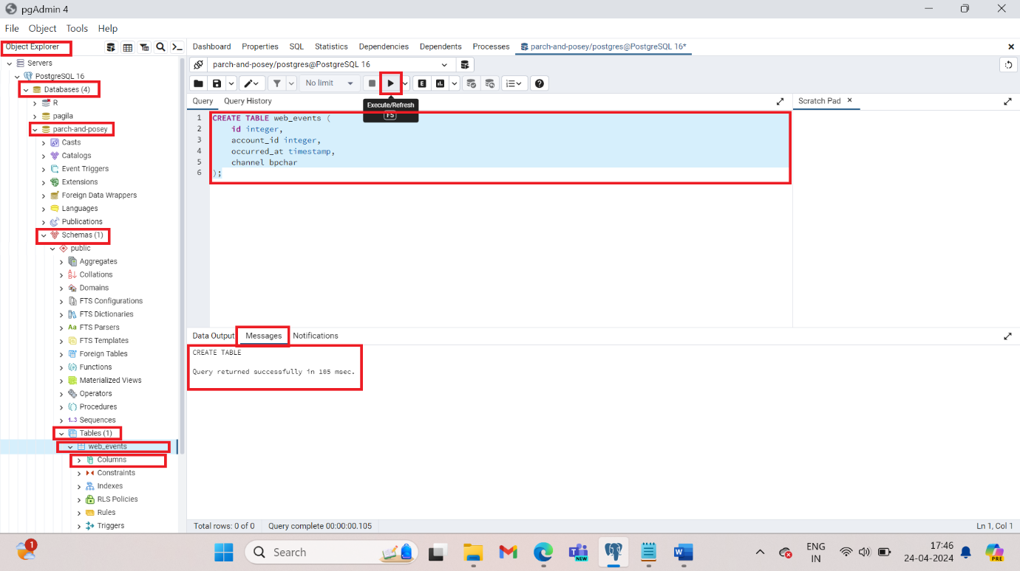

1. Now to insert values in this table type the following:  
   INSERT INTO web_events VALUES (1,1001,'2015-10-06 17:13:58','direct');

All the contents of this table can be found in the dataset folder web_events file. Run. This will return a message if the query was successful. This table consists of 9073 rows and 4 columns.

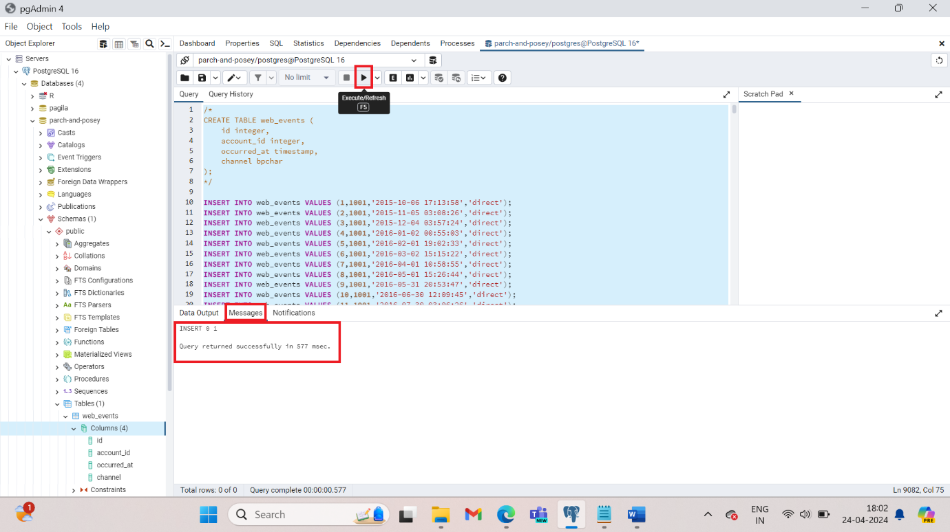

To comment a series od commands use the following symbols /* ----*/.

1. Similarly create tables sales_reps (50 rows and 3 columns), region (4rows and 2 columns), orders (6912 rows and 11 columns) and accounts (350 rows and 7 columns)

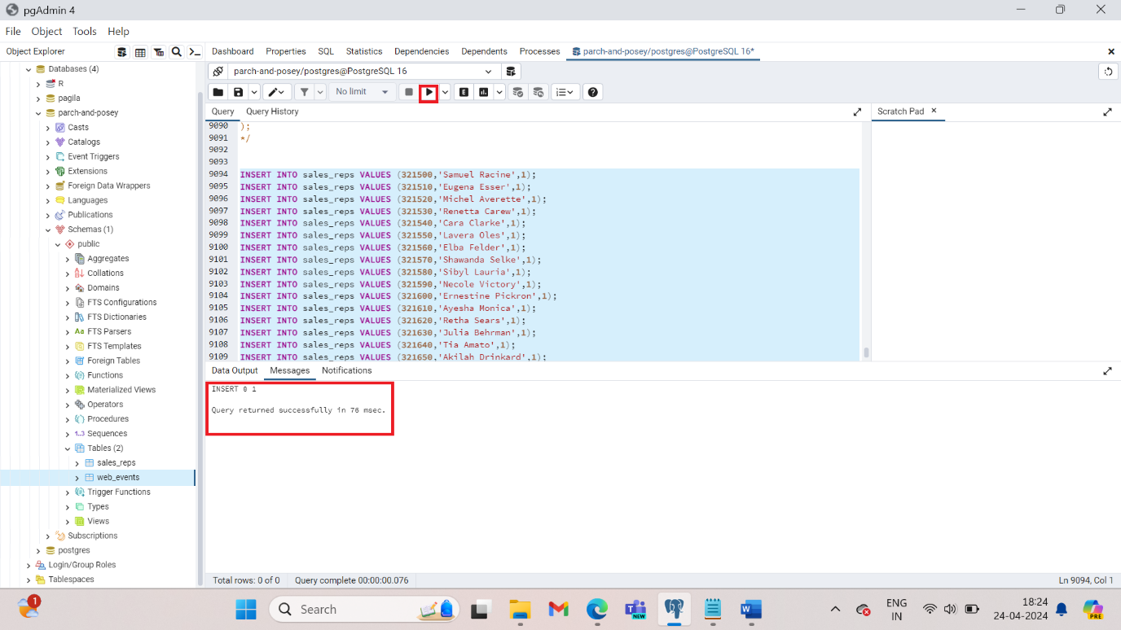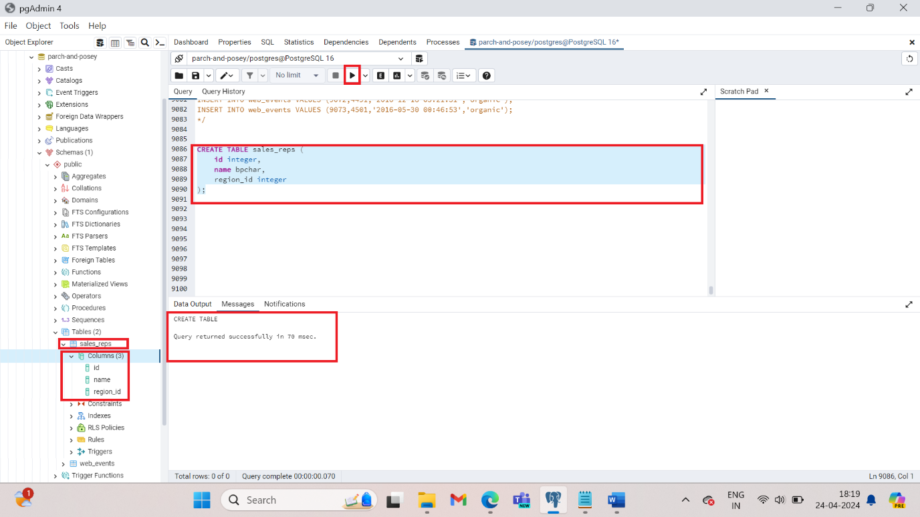

Now we have 5 tables created in our database.

